The History of Passive Houses and Passive Building
The concepts of superinsulation, airtight envelopes, energy recovery ventilation, high performance windows, and managing solar gain originated in the United States and Canada decades ago, a reaction to the OPEC oil embargo. In fact, American Nobelist Dr. William Shurcliff wrote in the 1980s about passive houses. For a summary of North America's pioneering energy history, see Katrin Klingenberg's blog post on the North American roots of the passive building movement.
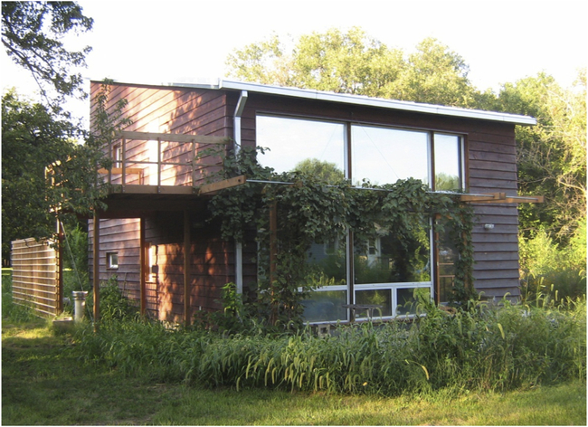
Interest in conservation waned in the United States for many years. During that time, the Europeans refined the application of these principles and spawned demand for high-performance products. Dr. Wolfgang Feist, a German physicist, and Dr. Bo Adamson, a Swedish scientist, led the effort to refine the principles and develop the design techniques and the Passivhaus performance metric. The first Passivhaus was built in Darmstadt, Germany. Feist went on to found the Passivhaus Institut (PHI), which is headquartered in Darmstadt.
PHIUS co-founder Katrin Klingenberg studied architecture in her native Germany. She discovered Passivhaus and, following Feist’s lead, endeavored to re-introduce the now-refined passive house principles to the United States in 2002 by building her own passive house residence in Urbana, Illinois. Unbeknownst to her at the time, the University of Illinois at Urbana-Champaign had been a hotbed of innovation in building energy efficiency in the 1970s and 1980s and was where the term "super-insulation" was first coined.
Since then interest has continued to grow in North America. Over that period, PHIUS’ Annual North American Passive House Conference has grown exponentially, drawing presenters, exhibitors, and attendees from around the world. It is the largest and most technically-focused such event in North America.
PHIUS worked collaboratively with PHI for several years and became a distributor of the PHI’s Passive House Planning Package (PHPP) Excel spreadsheet, the original passive house design software. PHIUS developed an Imperial system (inch-pound) version of that software, which greatly increased adoption in the United States. PHIUS also created a North American focused training program and created the Certified Passive House Consultant (CPHC®) credential.
Over time, PHIUS and PHIUS-trained professionals learned that in North America’s climate extremes, passive building concepts and standards require adaptation if they are to be practical, cost effective, and adopted widely enough to make a substantial difference. PHIUS also recognized the need to partner with major energy leaders such as the US Department of Energy (DOE), US Army Corps of Engineers, RESNET, Building Science Corporation (BSC), and Fraunhofer IBP in order to grow passive building principles from a boutique concept to mainstream adoption. This approach put PHIUS at odds with Germany’s PHI. PHI holds that a single metric should apply in all climate zones worldwide. PHI also objected to collaboration with the government and organizations such as RESNET.
Ultimately, it became clear that a single performance metric for all climate zones was not workable. Under a DOE Building America grant, the PHIUS Technical Committee, in partnership with BSC, developed a formula that yields climate specific, cost-effective performance targets. It was an exhaustive, three-year effort resulting in the release of the climate-specific and cost-effective PHIUS+ 2015 Passive Building Standard – North America in March of 2015. The new standard yields aggressive but attainable climate-specific building energy performance targets that substantially cut carbon emissions and energy consumption in buildings to provide superb comfort, superior indoor air quality, and resilience.

